System Architecture Diagram
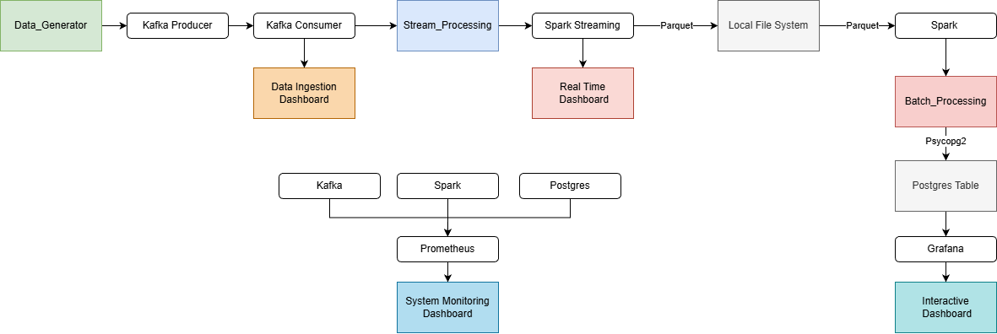
Dataflow Diagram
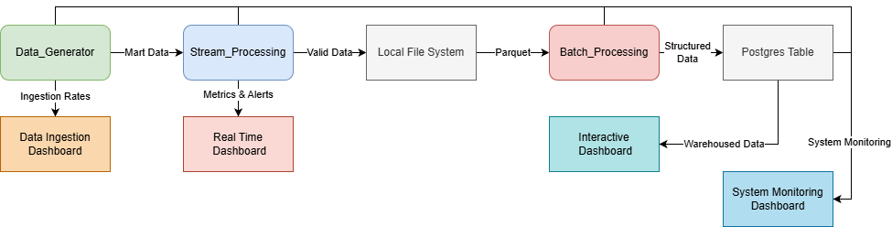
Technology selection justification
PostgreSQL:
Reliable, ACID-compliant relational storage
Ensures correctness and consistency for fact and dimension tables.
Powerful SQL engine
Ideal for analytics queries, joins, aggregations, and serving BI dashboards.
Grafana:

Prometheus:

Design decisions and trade-offs
Deterministic Data Generation:
+ No need for premade data
+ I/O and memory usage greatly reduced
+ Data is realistic and not fully random
- No session tracking
- Bootleg inventory tracking
Use of SCD 2 for Products:
+ Ability to track inventory correctly
+ Product history is saved
- Slow loading and not the best implementation

